**College of Applied Business and Technology**

**Sent-up Examination, March 2024**

**BIM / Fourth Semester / IT 307: Operating System**

*Candidates are required to give their answers in their own words as far as practicable. The figures in margin indicate full marks.*

**Section ‘A’ Time: 20 minutes**

**Very short answer questions. [Attempt ANY TEN] [10 × 1=10]**

1. Why should the operating system prevent users from accessing the boot sector?
2. Explain the difference between kernel and shell.
3. How virtual memory is differed from physical memory?
4. Describe deadlock in operating systems.
5. Why processes need to be synchronized?
6. Explain the difference between a mutex and a semaphore.
7. Explain the role of device drivers.
8. Explain the difference between preemptive and non-preemptive scheduling.
9. Define thrashing in operating systems.
10. Explain the purpose of a page table.
11. What is distributed operating systems?
12. What is a context switch?

**College of Applied Business and Technology**

**Sent-up Examination, March 2024**

**BIM / Fourth Semester / IT 307: Operating System**

*Candidates are required to give their answers in their own words as far as practicable. The figures in margin indicate full marks.*

**Section ‘B’**

**Time: 30 minutes**

**Short answer questions. [Attempt ANY TWO] [2 × 5=10]**

1. Define the primary role of an operating system in a computer system.
2. Discuss the challenges associated with deadlock in operating systems and potential solutions.
3. Consider a disk with the following free space (in blocks): [50, 20, 70, 40, 30]. Three files need to

be stored on the disk, each with the following sizes: File A requires 60 blocks, File B requires 25

blocks, and File C requires 35 blocks. Calculate First Fit, Best Fit and Worst Fit. Compare their effectiveness in terms of fragmentation and utilization of disk space.

**College of Applied Business and Technology**

**Sent-up Examination, March 2024**

**BIM / Fourth Semester / IT 307: Operating System**

*Candidates are required to give their answers in their own words as far as practicable. The figures in margin indicate full marks.*

**Section ‘C’ Time: 70 minutes**

**Long answer questions. [Attempt ANY TWO] [2×10=20]**

1. What is page fault and page hit? Consider following page reference string 1,2,3,4,2,1,5,6,2,1,2,3,7,6,3,2,1,2,3,6. How many page faults would occur in FIFO, Optimum and LRU replacement algorithm. Calculate hit ratio and miss ratio.
2. Write CPU scheduling criteria for the processes listed in following table, draw Gantt chart.

Illustrating their execution and calculate average waiting time and turnaround time using.

a). First Come First Sever (FCFS)

b). Shortest Remaining Time First (SRTF)

c). Highest Response Ratio Next (HRRN)

d). Priority (1 is higher)

e). RR (quantum = 2 sec)

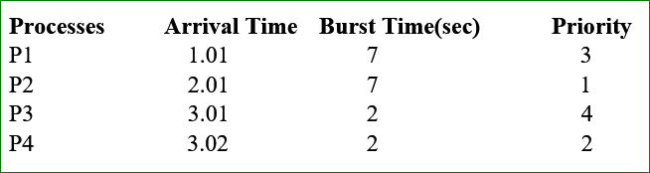

1. Suppose that a disk drive has 200 cylinders, numbered 0 to 199. The drive is currently serving a request at 53. The queue of pending request is 98,183,37,122,14,124,65,67. Starting from the current head position, calculate total head movement (in cylinder) that the disk arm moves to satisfy all the pending request for FCFS, SSF, SCAN, C-Scan, Look, C-Look disk scheduling algorithm.